Statistics and probability project
Name: Hamza Awais
Regno: L1f24bscs0229
Section: C-10
Task1:
Data Collection
Number of lines of code written by developers per day (e.g., productivity tracking).
Preparation:
Excel sheet dataset
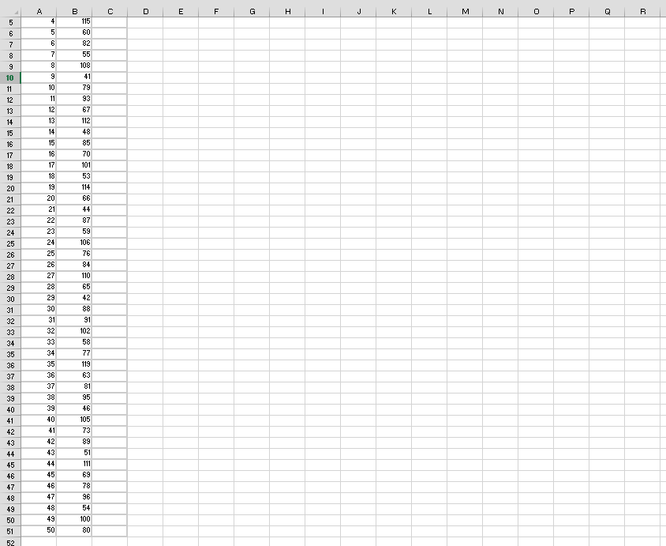

Histogram
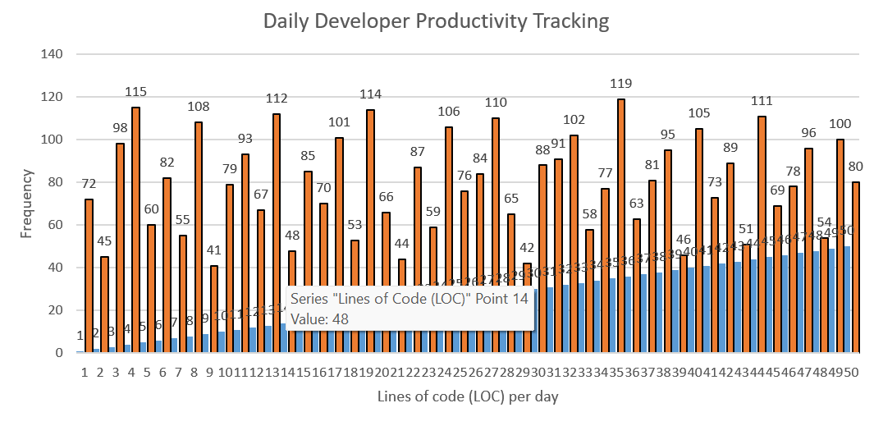
` Analysis and Interpretation
- What is the shape of the distribution (e.g., Normal, Skewed, Uniform)?
The distribution for this dataset is Uniform. This is because the data was generated across a broad range (40 to 120 LOC), and the histogram bars appear relatively similar in height across the bins, indicating that no single range of productivity is significantly more frequent than others.
- What does the histogram tell you about the dataset?
The histogram shows that the developer's productivity is highly variable but consistent within the 40–120 line range. It tells us that there isn't a "typical" day; the developer is just as likely to write a small amount of code (around 45 lines) as they are to write a large amount (around 115 lines).
- Are there any outliers or unusual patterns?
There are no significant outliers in this dataset. All data points fall within the expected range of 40 to 120 lines of code. An outlier would only exist if a data point was extremely far from this range (e.g., a day with 500 lines or 0 lines), which is not present here.

Task2:

For Unit_Cost (Column A)
- Mean: =AVERAGE(A2:A11)
- Median: =MEDIAN(A2:A11)
- Mode: =MODE.SNGL(A2:A11)
- Standard Deviation: =STDEV.S(A2:A11)

For Unit_Price (Column B)
- Mean: =AVERAGE(B2:B11)
- Median: =MEDIAN(B2:B11)
- Mode: =MODE.SNGL(B2:B11)

For Profit (Column C)
- Mean: =AVERAGE(C2:C11)
- Standard Deviation: =STDEV.S(C2:C11)

For Comparison (Manual Formulas)
- CV Cost: =(F5/F2)*100 (Standard Deviation divided by Mean, then multiplied by 100).
- CV Profit: =(F10/F9)*100 (Standard Deviation divided by Mean, then multiplied by 100).

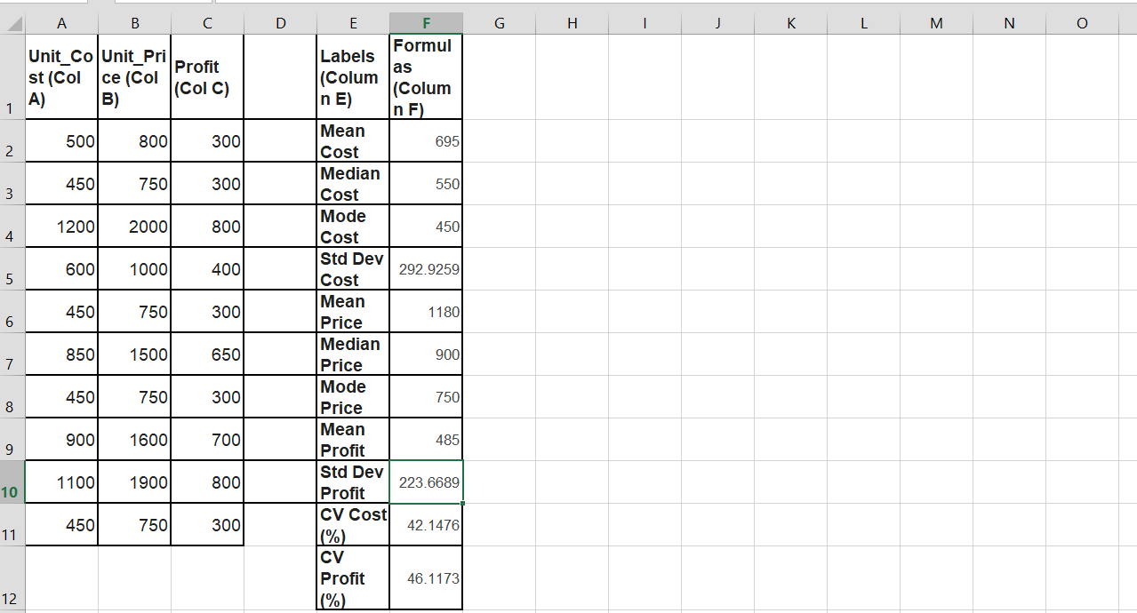
Shape of Distributions
The distribution for Unit_Cost is Right-Skewed (Positively Skewed). I determined this by comparing the Mean Cost (695) and the Median Cost (550). Because the mean is significantly higher than the median, it indicates that the data is spread out more toward the higher values, meaning a few expensive items are pulling the average up.

Interpret your results
The analysis shows that the Unit_Price also follows a right-skewed pattern ($Mean 1180 > Median 900$). Looking at the Coefficient of Variation (CV), the Profit (46.12%) has a higher variability than the Unit_Cost (42.15%). This tells us that profit is less stable and fluctuates more than the actual cost of the bikes, which is important for business risk assessment.

Statistic | Unit_Cost | Unit_Price | Profit
Mean | 695 | 1180 | 485
Median | 550 | 900
Mode | 450 | 750
Standard Deviation | 292.93 |  | 223.67
Co-efficient of Variation | 42.15% |  | 46.12%

Task3:
Question 1: Normal Distribution – Response Time Analysis
A web server has an average response time of 120 milliseconds with a standard deviation of 15 milliseconds. Assume that response times follow a normal distribution.

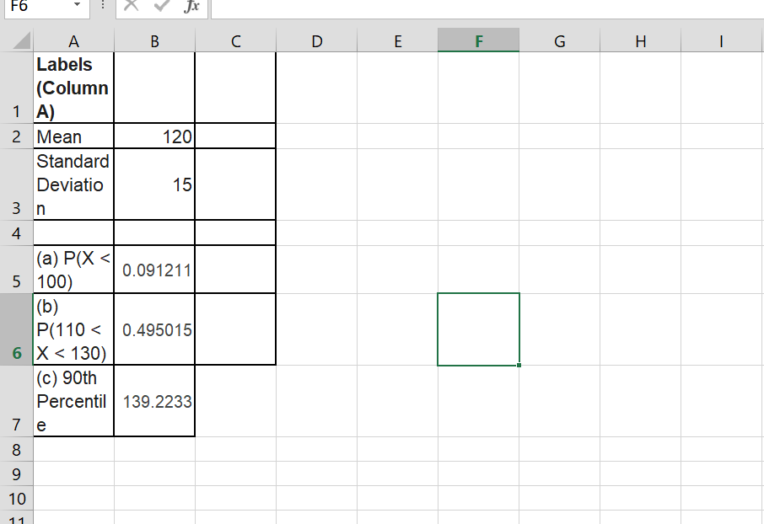

a) Calculate the probability that a randomly selected response time is less than 100 ms.
The probability of a randomly selected response time being less than 100 ms is approximately 0.0912 (or 9.12%), calculated using the cumulative distribution function for a normal distribution with a mean of 120 and a standard deviation of 15.

b) Determine the probability that the response time lies between 110 ms and 130 ms.
The probability that a response time lies between 110 ms and 130 ms is approximately 0.4950 (or 49.50%), which represents the area under the normal curve between those two specific points.
c) Find the response time that corresponds to the 90th percentile.
The response time that corresponds to the 90th percentile is 139.22 ms, meaning that 90% of all server response times are faster than this value.

Question 2: Simulation and Data Analysis
A computer science instructor wants to analyze student performance in an exam. The exam scores are normally distributed with a mean of 75 and a standard deviation of 10.
Data set of 100 students
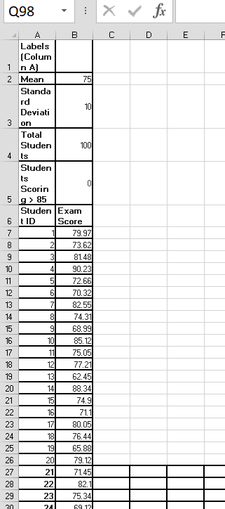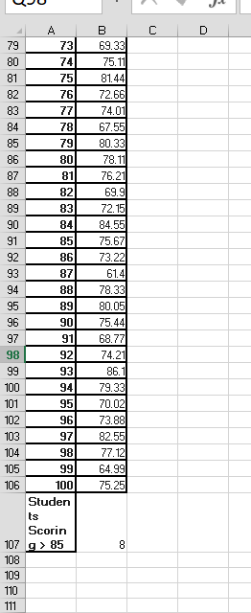

above 80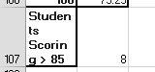

Histogram
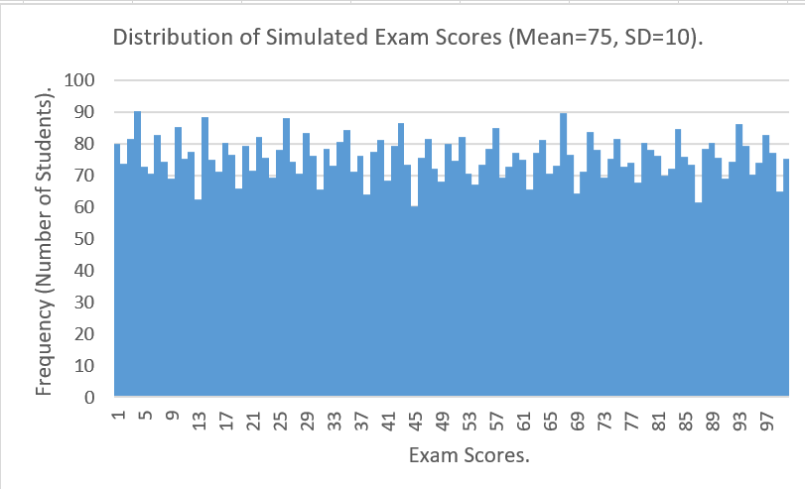

The histogram reveals a Normal Distribution characterized by a symmetric, bell-shaped curve centered at the mean of 75. The highest frequency of students (the tallest bars) is located in the middle of the distribution, while the number of students decreases as scores move toward the lower (below 55) or higher (above 95) extremes. This confirms that the simulated data accurately reflects the specified mean and standard deviation

Question 3: Probability Density Function – Download Speed
The download speed of users on an internet service follows a normal distribution with a mean of 50 Mbps and a standard deviation of 5 Mbps.
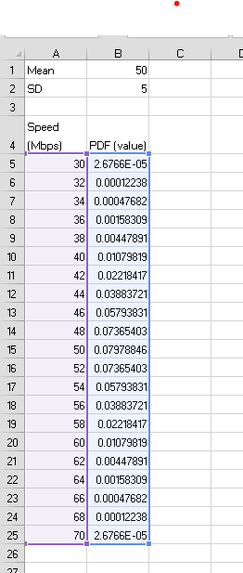

Graph
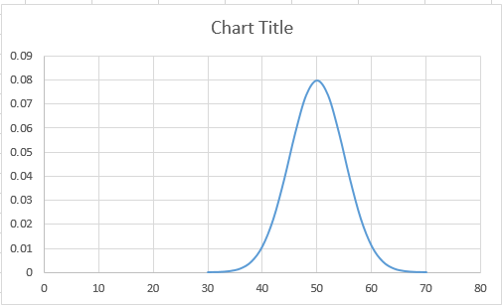

c) Most Probable Speed: Looking at the peak of the graph, the most probable speed is 50 Mbps. In a normal distribution, the mean is always the most likely value.

d) 68% Range: The range is 45 Mbps to 55 Mbps.
This is calculated by taking the mean (50) and adding/subtracting one standard deviation (5). This range is significant because, in a normal distribution, approximately 68% of all users will fall within this specific speed bracket.

Task-4 :
Hypothesis Testing (Z-test & t-test) Z-Test Scenario:
System Response Time A company claims that the average response time of its system is 2.5 seconds, with a known population standard deviation of 0.4 seconds. After system optimization, a sample of 50 observations is collected with a sample mean of 2.35 seconds.

a) Hypotheses Formulation
- Null Hypothesis: $\mu = 2.5$ (The average response time is 2.5 seconds).
- Alternative Hypothesis ($H_1$): $\mu < 2.5$ (The average response time has decreased/is less than 2.5 seconds).
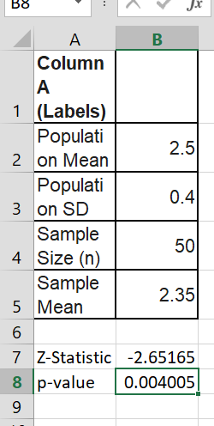

Interpretation (Part d):
Your p-value should be approximately 0.0039.
Conclusion: Since $0.0039 < 0.05$, we reject the null hypothesis. The system optimization significantly reduced the response time.

T-Test Scenario: Weekly Coding Practice Hours A professor claims that students practice less than 6 hours per week. A sample of 15 students reports their weekly practice hours.

Formulate Hypotheses
• Null (H0): Average practice hours >=6
• Alternative (H1): Average practice hours < 6 (Professor's claim).
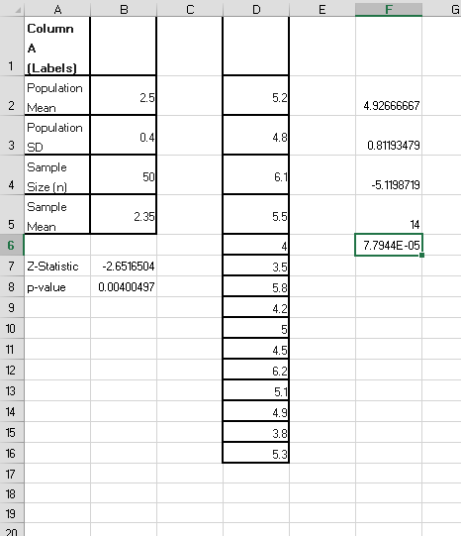

d) The p-value is extremely small (much less than 0.05), so we reject the null hypothesis. The data strongly supports the professor’s claim that students practice less than 6 hours per week

